Task

On

Machine Learning

**Course**: Artificial Intelligence

(Machine Learning & Deep Learning)

Name: Abbas Shafi

Father Name: Dr Muhammad Shafi

Week: 12

Submitted to: Sir Syed Nazir Afridi



National Vocational & Technical Training Commission

National Center For Big Data & Cloud Computing

University of Engineering & Technology

Peshawar

[1]:

**import numpy as np import pandas as pd**

**import matplotlib.pyplot as plt**

**from statsmodels.tsa.seasonal import** seasonal_decompose

[3]:

[4]:

1. : Year-Month Passengers

0 1949-01 112

1 1949-02 118

2 1949-03 132

3 1949-04 129

4 1949-05 121

[5]:

1. : Year-Month object Passengers int64 dtype: object

[7]:

[8]:

[8]: Year-Month datetime64[ns] Passengers int64 dtype: object

[9]:

|  |  |  |
| --- | --- | --- |
| [9]: | Year-Month | Passengers |
|  | 0 1949-01-01 | 112 |
|  | 1 1949-02-01 | 118 |
|  | 2 1949-03-01 | 132 |
|  | 3 1949-04-01 | 129 |
|  | 4 1949-05-01 | 121 |

[10]:

[11]:

|  |  |  |
| --- | --- | --- |
| [11]: | Year-Month | Passengers |
|  | 1949-01-01 | 112 |
|  | 1949-02-01 | 118 |
|  | 1949-03-01 | 132 |
|  | 1949-04-01 | 129 |
|  | 1949-05-01 | 121 |

[12]:

|  |  |  |
| --- | --- | --- |
| [12]: | Year-Month | Passengers |
|  | 1960-08-01 | 606 |
|  | 1960-09-01 | 508 |
|  | 1960-10-01 | 461 |
|  | 1960-11-01 | 390 |
|  | 1960-12-01 | 432 |

[13]:

|  |  |  |
| --- | --- | --- |
| [13]: | Year-Month | Passengers |
|  | 1951-04-01 | 163 |
|  | 1951-05-01 | 172 |
|  | 1951-06-01 | 178 |
|  | 1951-07-01 | 199 |
|  | 1951-08-01 | 199 |
|  | 1951-09-01 | 184 |
|  | 1951-10-01 | 162 |
|  | 1951-11-01 | 146 |
|  | 1951-12-01 | 166 |
|  | 1952-01-01 | 171 |

1952-02-01 180

1952-03-01 193

[14]:

[14]: Passengers 472

Name: 1960-05-01 00:00:00, dtype: int64

[15]:

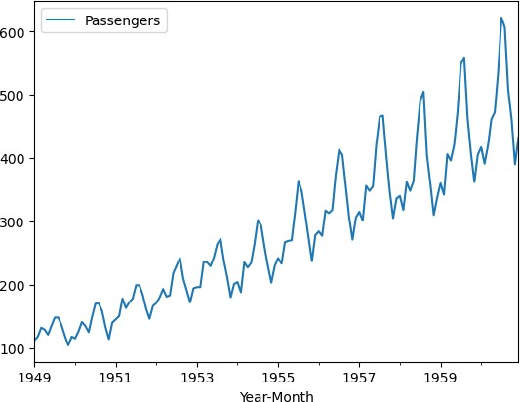

[16]:

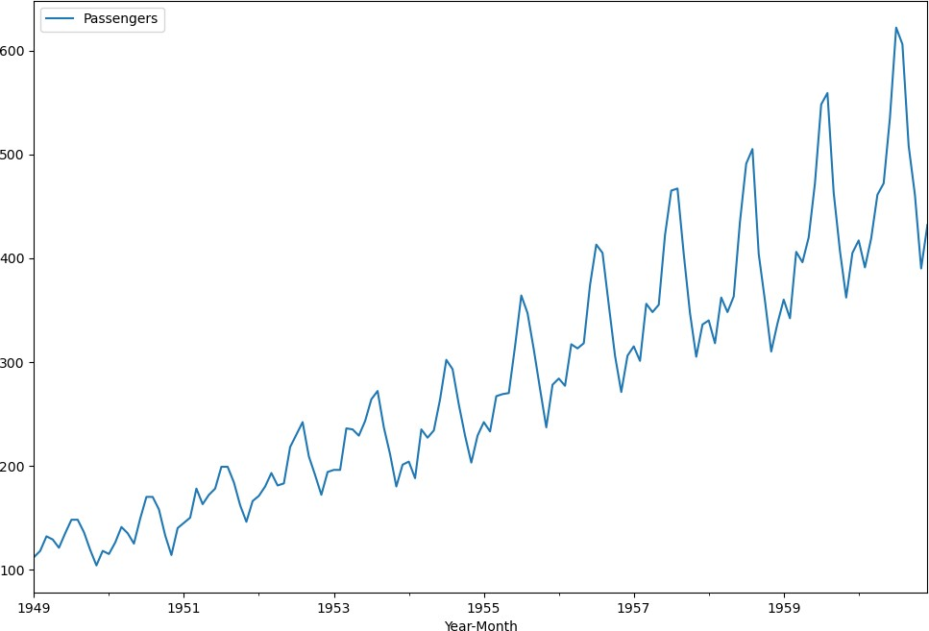

[17]:

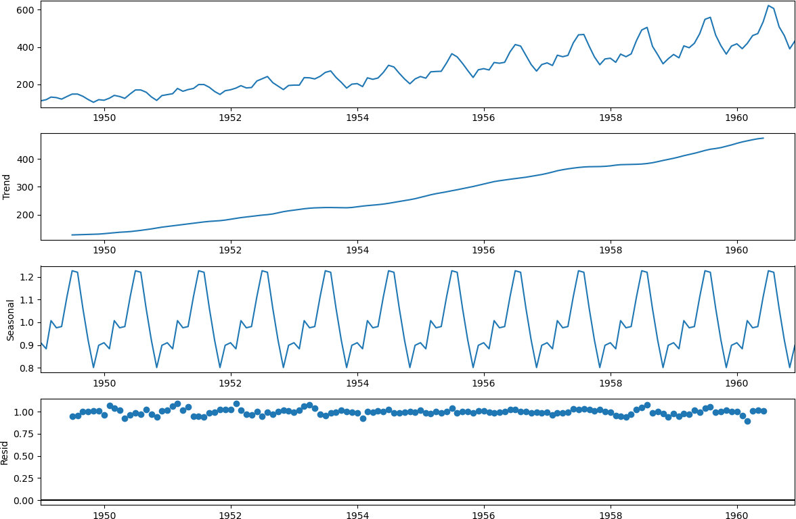

[18]:

|  |  |  |
| --- | --- | --- |
| [18]: | Year-Month | Passengers |
|  | 1949-01-01 | 112 |
|  | 1949-02-01 | 118 |
|  | 1949-03-01 | 132 |
|  | 1949-04-01 | 129 |
|  | 1949-05-01 | 121 |

[19]:

[20]:

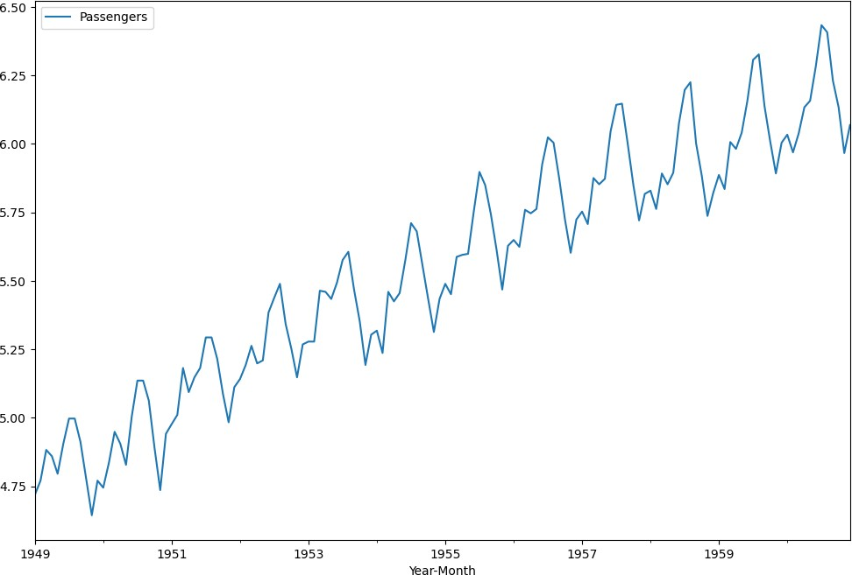

[23]:

*#Compare with orignal series* plt.subplot(2,1,1) plt.title("Orignal time Series") plt.plot(df1)

plt.subplot(2,1,2) plt.title("Transfomed time Series") plt.plot(df1_log)

plt.tight_layout()

<ipython-input-23-919a11664724>:2: MatplotlibDeprecationWarning: Adding an axes using the same arguments as a previous axes currently reuses the earlier instance. In a future version, a new instance will always be created and returned. Meanwhile, this warning can be suppressed, and the future behavior ensured, by passing a unique label to each axes instance.

plt.subplot(2,1,1)

<ipython-input-23-919a11664724>:6: MatplotlibDeprecationWarning: Adding an axes using the same arguments as a previous axes currently reuses the earlier instance. In a future version, a new instance will always be created and returned. Meanwhile, this warning can be suppressed, and the future behavior ensured, by passing a unique label to each axes instance.

plt.subplot(2,1,2)

[ ]: